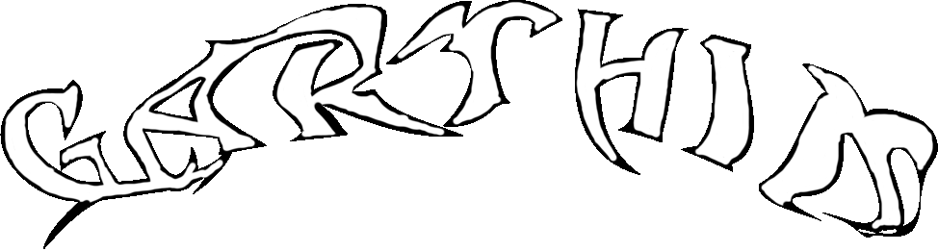

Press release:

“Ditch Number 3” by Jacob Mattingly at Garthim, Los Angeles

Garthim is proud to present “Ditch Number 3,” a solo exhibition of new paintings by Maryland based artist Jacob Mattingly. Pictures which suggest an amoebic universe are nestled in the crotch of a 7,000 foot peak; a growth on the face of a giant alight with foreign, inorganic pigments.